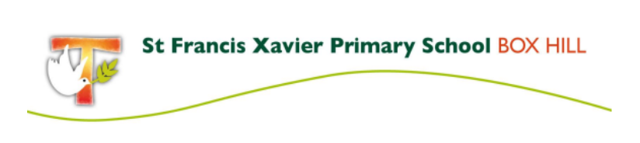

Fee Schedule 2022

2022 School fees include a Family Fee of $2,560 per family plus a Student Levy for each student:

Year Level | Student Fee
Prep | $770.00
Year 1 | $770.00
Year 2 | $770.00
Year 3 | $814.00
Year 4 (including camp) | $1014.00
Year 5 (including camp) | $1074.00
Year 6 (including camp) | $1074.00

The Student Levy covers the cost of items such as classroom materials, IT, books, excursions and incursions, a camp for Year 4-6, swimming classes (new from 2022) and other educational resources and programs.

Camps, Sports and Excursion Fund (CSEF)
Families holding a valid means-tested concession card or who are temporary foster parents are eligible to apply for a Victorian Government CSEF payment. $125 per year is paid for eligible primary school students. Payments are made directly to the school and enable the student to attend activities like school camps, swimming programs, sports programs, excursions and incursions. Application forms are available from the school office.
MACS Concessional Fee Policy
To assist school families in accessing a Catholic primary education for their child/children, the Melbourne Archdiocese of Catholic schools has introduced a concessional fee policy commencing in 2022.

The following families are strongly encouraged to apply:
- Any family of Aboriginal or Torres Strait Islander heritage
- Any family holding an HCC and eligible for CSEF
- Any family holding a DVA Gold Card
- Any family identified as refugees and holding an ImmiCard
- Any family experiencing significant financial hardship
For more information regarding the policy, please contact Donna Spaulding via phone at 9890 1108 or email dspaulding@sfxboxhill.catholic.edu.au

