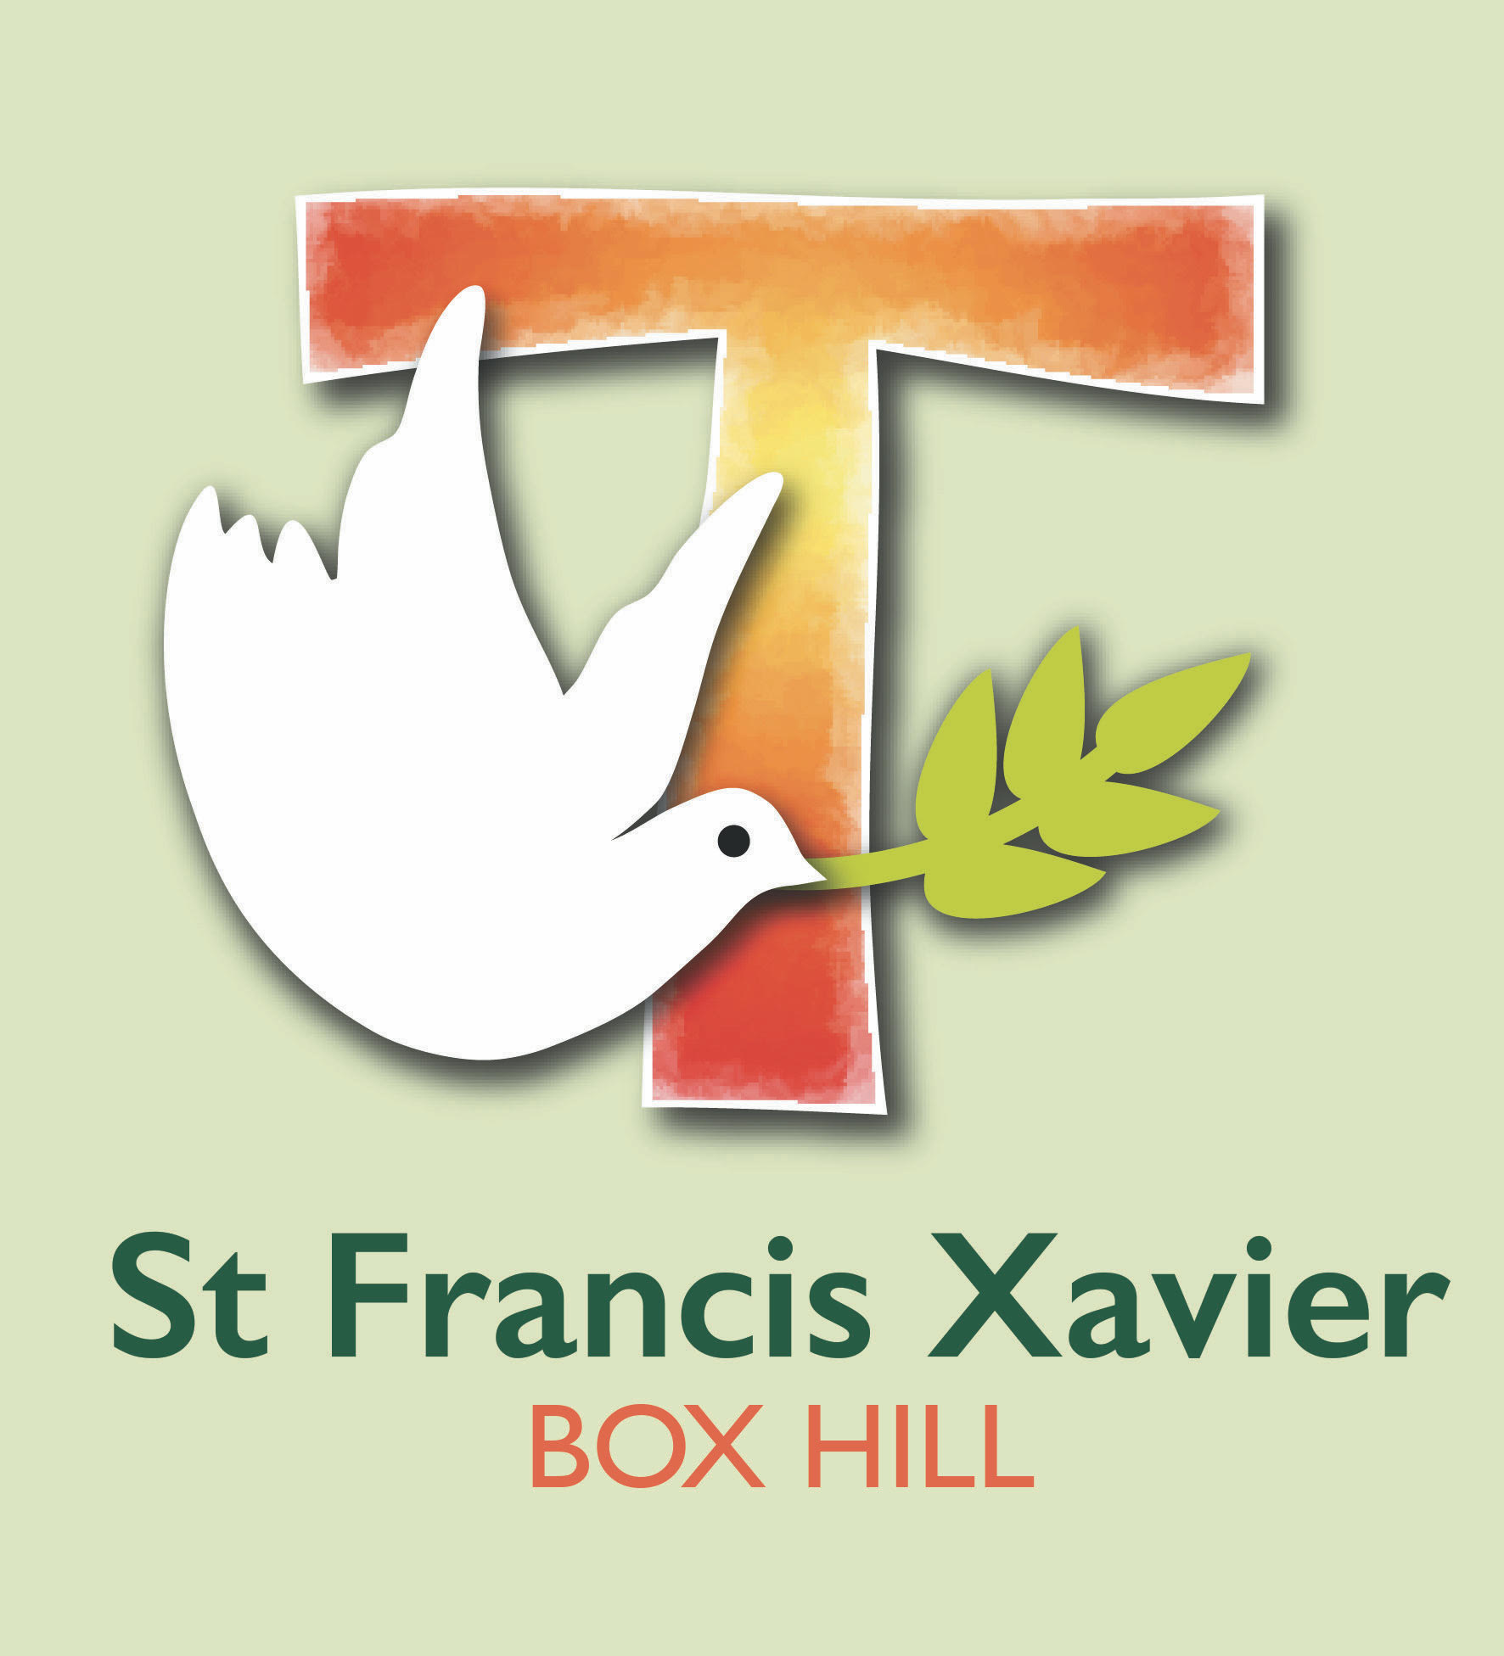
St Francis Xavier
Student Code of Conduct
St Francis Xavier is a school that operates with the consent of the Catholic Archbishop of Melbourne and is owned, operated and governed by Melbourne Archdiocese Catholic Schools Ltd (MACS).

Purpose
St Francis Xavier is committed to ensuring a respectful learning environment that is safe, positive and supportive for all students of the school.
It is the intention of St Francis Xavier to provide clear guidelines to all students regarding the conduct expected of them while at school, engaging in school-related activities or representing the school. Students are expected to uphold the school’s core values at all times.

Application
This Code of Conduct applies to all St Francis Xavier students. The application of this code is not limited to the school site and school hours. It extends to all activities and events that are school-related and when representing or acting on behalf of the school, including, without limitation, at all times when wearing the school uniform. The code also requires that student actions do not bring the school into disrepute at any time, regardless of whether the action occurs within or outside of school activities.

Basic Principles
This Code of Conduct is based on the following principles that everyone at St Francis Xavier:
- has the right to be safe
- has the right to be treated with respect and be valued, even in diversity
- has the right to participate within a secure environment without interference, intimidation, harassment, bullying or discrimination
- is encouraged to be respectful, polite, courteous and considerate of others
- has the right to be supported and challenged as ongoing learners.

Expected Conduct and Bearing of all Students
It is expected that every student will:
- uphold the school’s core values at all times
- behave in a manner that does not endanger the health, safety and wellbeing of themselves or others
- abide by all health and safety rules and procedures operating within the school and other locations at which the students may visit
- ensure that their actions do not bring the school into disrepute
- respect the authority of members of staff and observe school rules and teacher directions as required
- strictly adhere to the Student ICT Responsible Use Agreement
- be respectful and supportive of the school’s beliefs and values
- behave with courtesy and consideration for others
- refrain from all forms of bullying, harassment, racial vilification and discrimination of any nature
- report any behaviour of other students that is harmful to other students, or to the teachers or school
- support other students, or seek help for other students who need assistance or are in a vulnerable situation
- refrain from behaviour that would interrupt the work of any class or hinder the learning opportunities of other students
- respect school property and the property of staff, contractors, visitors and other students
- be punctual and attend all classes
- remain in the school grounds during the school day unless otherwise approved by the principal
- complete work set by teachers promptly and to the best of their ability and to take full advantage of the educational opportunities offered at the school
- dress neatly and with due regard for health, hygiene and safety in accordance with the school’s uniform requirements.

Unacceptable Conduct
Unacceptable conduct includes, but is not limited to:
- touching, handling, pushing or otherwise physically or sexually engaging with students or others in a manner that is not appropriate and may endanger the health, safety and wellbeing of that person
- any form of physical or verbal violence (including fighting, assault or threats of violence, bullying, name-calling, racial discrimination or discrimination on grounds of disability, appearance or religion)
- any form of cyberbullying or cyber abuse
- theft or misuse of property belonging to other students or the school
- sending inappropriate, offensive or explicit text messages, photos or videos
- language or conduct which is likely to offend, harass, bully or unfairly discriminate against any student, teacher, contractor or visitor
- the use of inappropriate or profane words or gestures and images
- unacceptable class attendance levels
- being uncooperative with teachers during class or school activities and generally disrupting planned activities.

Supporting Positive Behaviour
The school’s Behaviour Management Policy is based on a model of Positive Behaviour Support. This is a model that acknowledges the positive behaviour of the majority of students, and puts strategies into place to model and specifically teach expected behaviours. It targets focused support, including staged sanctions, for the minority of students that do not embrace positive behaviour.

Breach of the Student Code of Conduct
Students who breach this code of conduct may be sanctioned by the class teacher or school principal as deemed appropriate given the nature of breach and the age of the student.
In cases of serious and/or persistent breaches of the student code of conduct, the St Francis Xavier Behaviour Management Policy outlines the consequences for student misbehaviour and the management of suspension and expulsion if matters come to those extremes.
In accordance with applicable legislation and the school’s Child Safety Policy, the police and/or ‘Families and Children’s Services’ within the Department of Families, Fairness and Housing (DFFH) will be informed of any unlawful breaches of this code.

NAME OF STUDENT: |  | Date:
SIGNATURE OF STUDENT: |  | Date:
SIGNATURE OF PARENT/ GUARDIAN/CARER: |  | Date:

