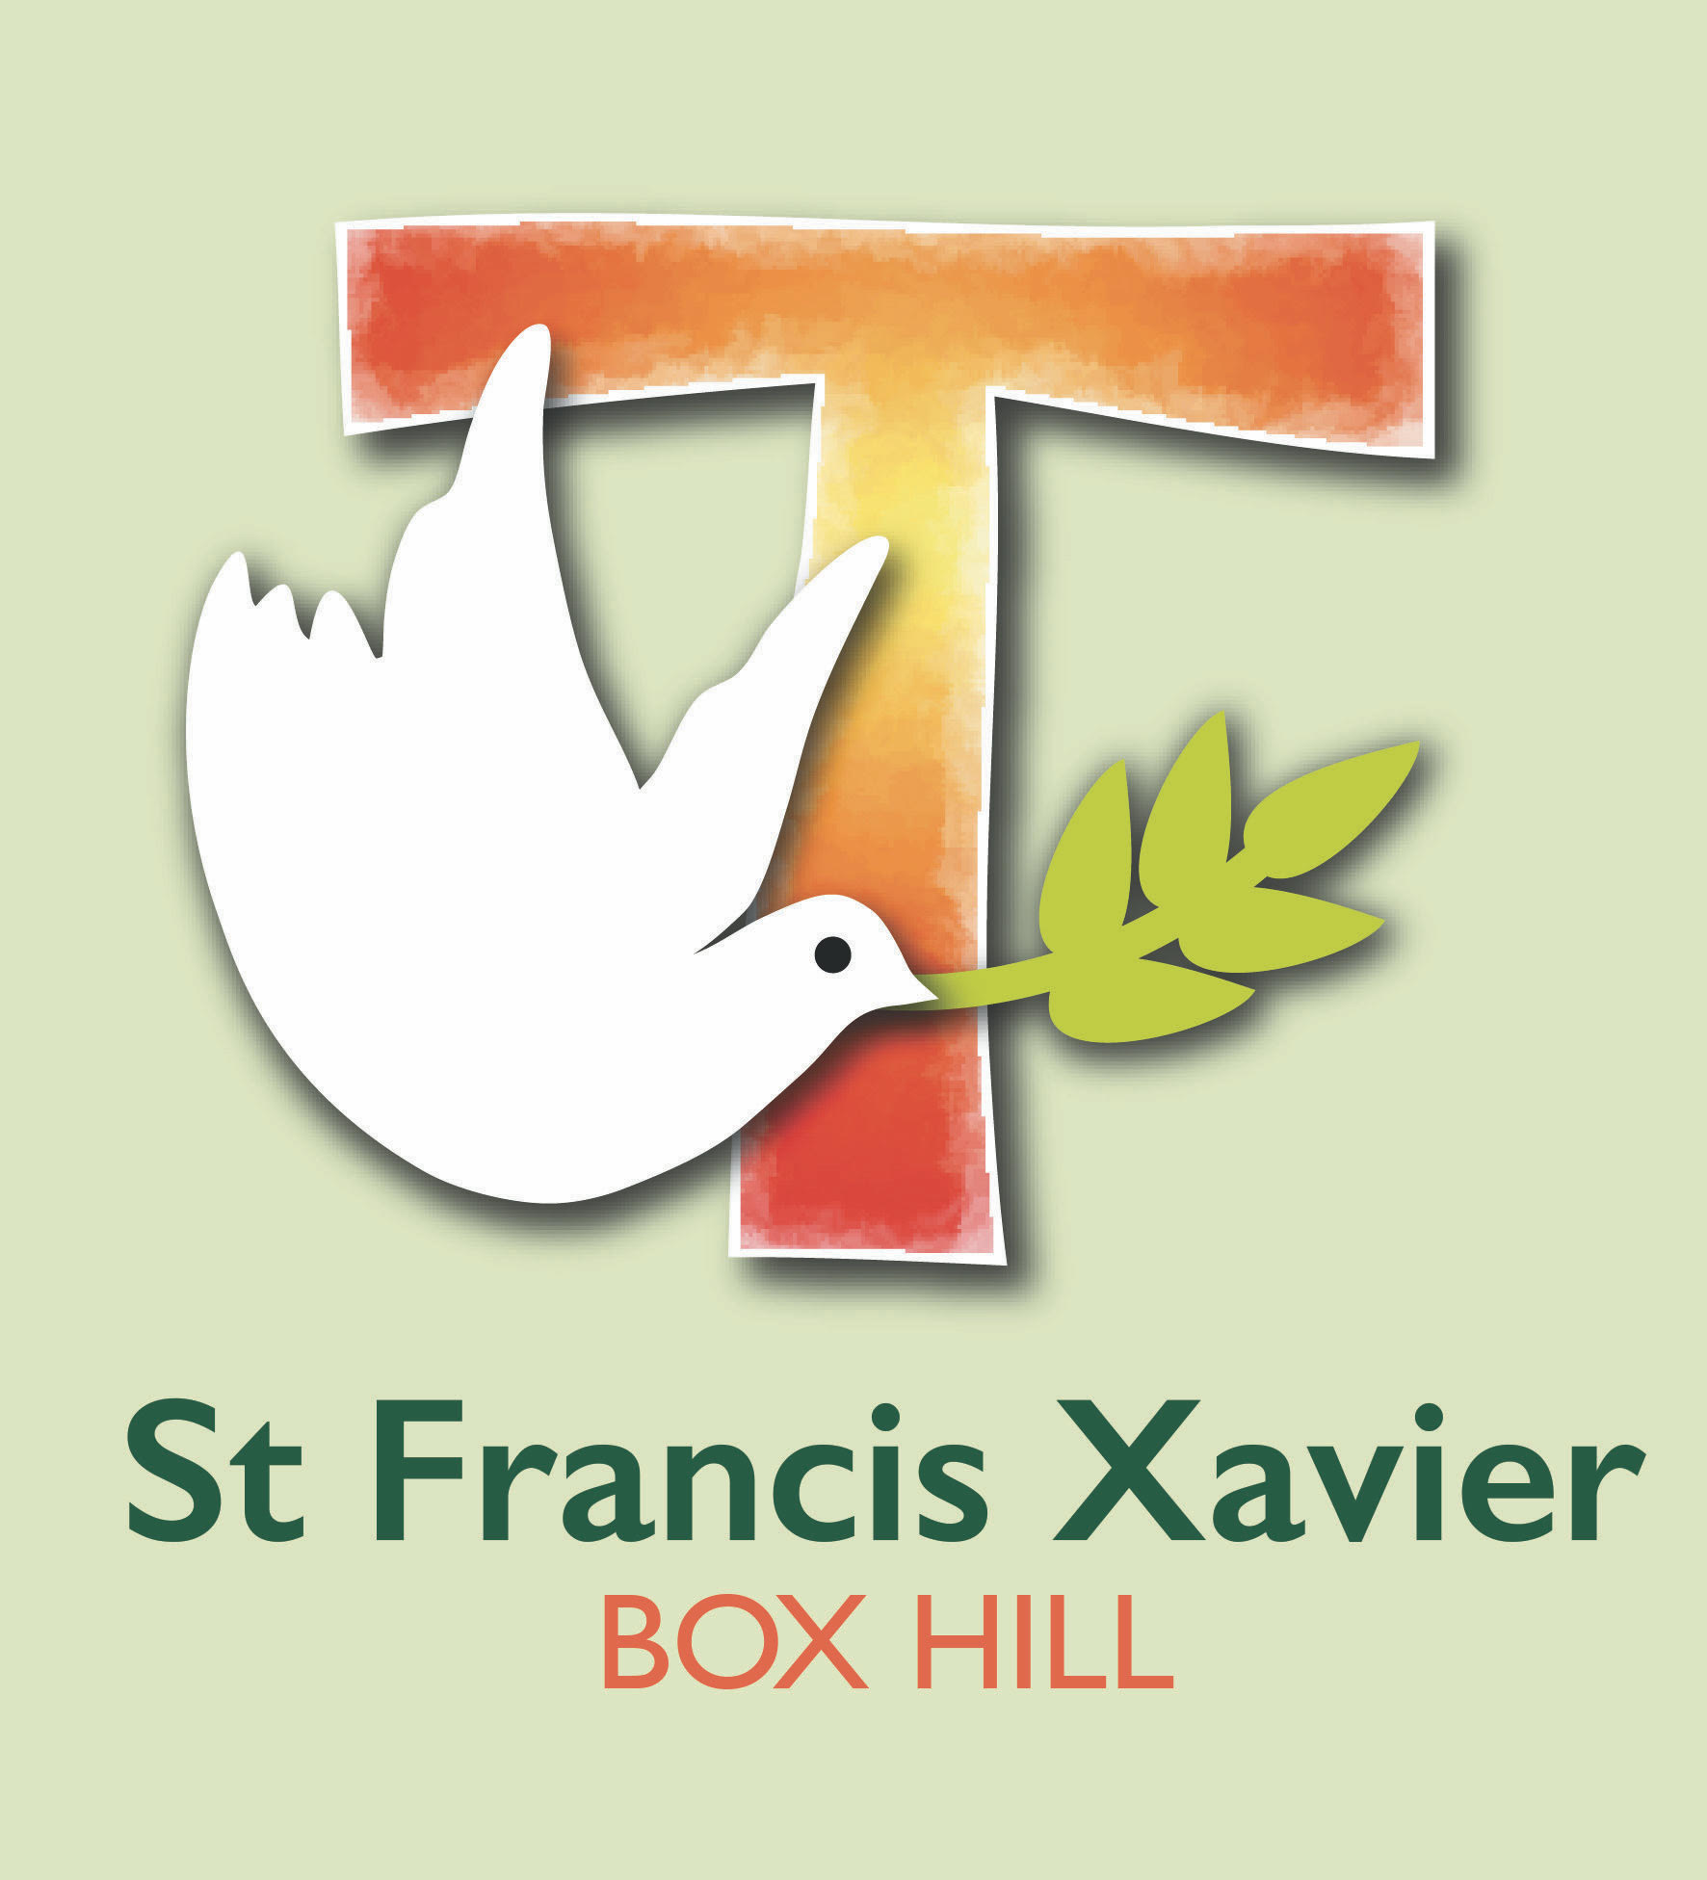
St Francis Xavier is a school that operates with the consent of the Catholic Archbishop of Melbourne and is owned, operated and governed by Melbourne Archdiocese Catholic Schools Ltd (MACS).
St Francis Xavier
Parent/Guardian/Carer
Code of Conduct

Purpose
St Francis Xavier is committed to ensuring a respectful learning environment that is safe, positive and supportive for all students, staff and visitors of the school.
It is the intention of St Francis Xavier to provide clear guidelines to all parents and visitors regarding the conduct expected of them while on the school premises, engaging in school-related activities or representing the school. Parents/guardians/carers and visitors are expected to uphold the school’s core values at all times.

Application
This Code of Conduct applies to all St Francis Xavier parents, guardians, carers and visitors to the school. The application of this code is not limited to the school site and school hours. It extends to all activities and events that are school-related and when visiting or representing the school, including, without limitation, at all times when wearing the school uniform. The code also requires that parent/guardian/carer or visitor actions do not bring the school into disrepute at any time, regardless of whether the action occurs within or outside of school activities.

Basic Principles
This Code of Conduct is based on the following principles that everyone at St Francis Xavier:
- has the right to be safe
- has the right to be treated with respect and be valued even in disagreement
- has the right to participate within a secure environment without interference, intimidation, harassment, bullying or discrimination
- is encouraged to be respectful, polite, courteous and considerate of others
- has the right to be supported and challenged as ongoing learners.

Expected Conduct and Bearing of all Parents/Guardians/Carers
It is expected that every parent/guardian/carer will:
- uphold the school’s core beliefs and values
- behave in a manner that does not endanger the health, safety and wellbeing of themselves or others
- abide by all health and safety rules and procedures operating within the school and other locations at which they may visit while representing the school
- ensure that their actions do not bring the school into disrepute
- respect school staff and accept their authority and direction within the exercise of their duties at the school
- observe all school rules as required
- strictly adhere to the school’s policies and procedures as required
- behave with respect, courtesy and consideration for others
- refrain from all forms of bullying and harassment
- refrain from any form of verbal insult or abuse and from any form of physical abuse or intimidation
- refrain from activities, conduct or communication that would reasonably be seen to undermine the reputation of the school, employees or students of the school, including activities on social media
- respect school property and the property of staff, contractors, volunteers and other students
- not be intoxicated by alcohol or under the influence of illicit drugs or other substances harmful to health while visiting the school site, attending school functions or engaging in school-based activities
- respect school staff and accept their authority and direction within the exercise of their duties at the school
- use the school’s Complaints Handling Policy to seek resolution for any problems that arise, and accept the school’s procedures for handling matters of complaint.

Unacceptable Conduct
Unacceptable conduct includes, but is not limited to:
- touching, handling, pushing or otherwise physically or sexually engaging with students, children or others in a manner that is not appropriate and may endanger the health, safety and wellbeing of that person
- any form of physical or verbal violence including fighting, assault or threats of violence
- approaching a child that is not your own with a view to disciplining that child for their behaviour.
- Such matters are only to be dealt with by school staff
- approaching other school parents to resolve issues arising between students at school. Such matters should be referred to school staff
- any form of cyberbullying or cyber abuse that is directed towards the school, staff members, students or parents or any member connected to the school
- any form of threatening language, gestures or conduct
- language or conduct which is threatening or likely to offend, harass, bully or unfairly discriminate against any student, employee, contractor, volunteer or other
- corresponding or communicating with school staff in a manner which is unreasonable (including for example, via email or app’s) in terms of the frequency or volume of communications, or the nature or tone of such communications
- theft, fraud or misuse of school resources
- the use of inappropriate or profane words or gestures and images
- visiting the school, attending social, sporting or other functions while intoxicated by alcohol or under the influence of illicit drugs or other substances harmful to health
- smoking on the school premises or within the immediate environs of the school
- claiming to represent the school in any matter without explicit permission from the school principal to do so.

Breach of the Code of Conduct
Parents/guardians/carers who breach this code of conduct will be contacted by the school principal. Appropriate action, which may include being banned from coming onto school grounds, attending school functions or school-based activities or, setting mandatory parameters around methods and timing of communication, is at the discretion of the school principal.
Parents/guardians/carers who continually breach this Code of Conduct or who engage in a significant and/or serious breach will be referred to the principal, who has full discretion to take or to seek the taking of action which may include termination of this enrolment agreement.
Termination of this enrolment agreement may occur in circumstances where any parent/guardian/carer repeatedly breaches the Code of Conduct (after the parent/guardian/carer, or the family collectively, has been warned that any further breach may result in termination of enrolment), or should any parent/guardian/carer engage in conduct on a single occasion which constitutes a serious breach of the Code of Conduct (involving, for example, conduct which poses a serious risk to staff or student health and safety), the circumstances may result in a termination of their child’s enrolment.
A decision to withdraw or terminate the enrolment of a student may only be made by the Director, Learning and Regional Services upon consideration of the following:
- the view of the principal of the school
- an objective assessment of all presenting circumstances.
Before any final decision as to the termination of enrolment is made, the student’s family will be provided with an opportunity to comment on and/or provide any relevant information for consideration in this regard.
In accordance with applicable legislation and the school’s Child Protection Policy, the police and/or ‘Families and Children’s Services’ within the Department of Families, Fairness and Housing (DFFH) will be informed of any unlawful breaches of this code.

NAME OF PARENT/GUARDIAN /CARER: | Signature: | Date:

