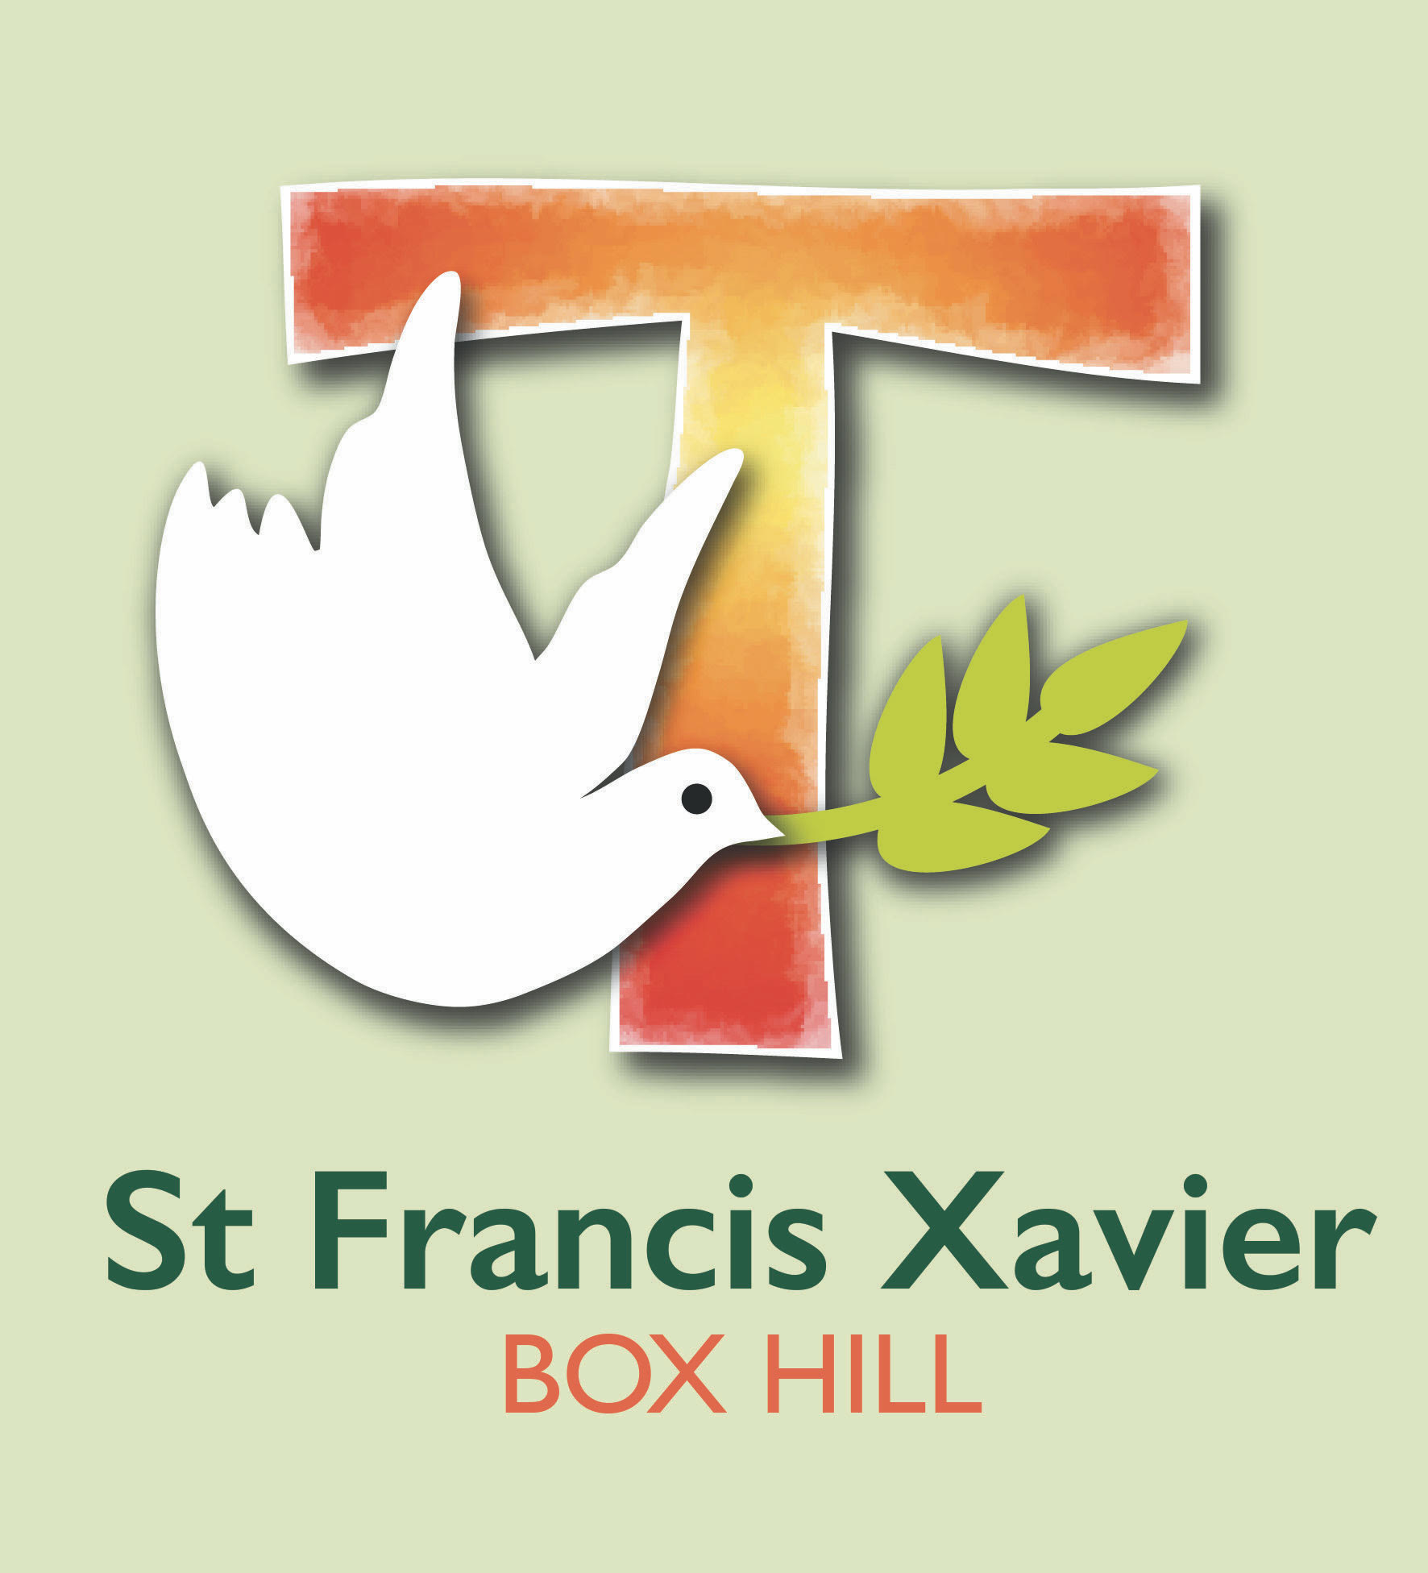
St Francis Xavier
Dependant Full-fee Paying Overseas Students Application
St Francis Xavier is a school that operates with the consent of the Catholic Archbishop of Melbourne and is owned, operated and governed by Melbourne Archdiocese Catholic Schools Ltd (MACS).

Purpose
This application form is only for International parents studying or planning to study in Victoria and who wish to enrol their child in a school governed and operated by MACS.
Complete this form for visa subclasses: 500 Student – Higher Education Sector; 500 Student – Vocational Education and Training (VET); 500 Student – ELICOS and 500 Student – Non-Award. Children of parents who are studying at a Victorian University for research purposes are fee-exempt and can complete the enrolment procedure at the individual school (i.e. students applying for or holding a 500 Student – Masters and Doctorate or 500 Student – AusAID and Defence visa)

Application procedure
- Parent/Guardian/Carer to gather supporting information
- Parent/Guardian/Carer to apply for enrolment directly to a School, using the attached Dependent Full-Fee Paying Overseas Students (FFPOS) Application Form, with all supporting information and the application fee
- Parent/Guardian/Carer will be required to pay an Enrolment Application Fee to MACS at the time of submission of the application
- School to submit a Dependent Full-Fee Paying Overseas Students (FFPOS) Application, together with the Enrolment Application Fee, to the MACS Executive Director (or the delegate of the MACS Executive Director) for approval.
- Upon approval, MACS to issue a letter of offer and invoice
- Parent/Guardian/Carer to accept and pay tuition fee

Fee information
Application Fee
Applications must be accompanied by the payment of the application fee. Payment must be made as detailed in the Dependent Full-Fee Paying Overseas Students (FFPOS) Application Form. The application fee is non-refundable.
Tuition Fee, levies and ad hoc charges
Tuition fees, levies and ad hoc charges can be paid by credit card, bank draft, bank cheque, money order, BPay (within Australia only) or telegraphic transfer, made payable to the individual school. The preferred method of payment is direct debit set up at the time of enrolment.
Tuition fees do not include fees and charges for books, uniforms, stationery items, school trips, camps, visa application or travel costs, excursion/school activities.

Terms and conditions
The Dependant Full-Fee Paying Overseas Students (FFPOS) Application form will not be processed unless all relevant sections have been completed and all requested documentation is attached.
The student’s parent or legal guardian must sign the Dependent Full-Fee Paying Overseas Students (FFPOS) Application form where stated in the Parent’s/Guardian's Declaration section.
Age requirements
The minimum age for a dependant international student to commence school is 5 years old as of 30 April of the year of enrolment.
The maximum age for enrolment at a Victorian government school at the commencement of school is as follows:
- entering Year 9 – the student must be less than 17 years of age
- entering Year 10 – the student must be less than 18 years of age
- entering Year 11 –the student must be less than 19 years of age
- entering Year 12 –the student must be less than 20 years of age.

