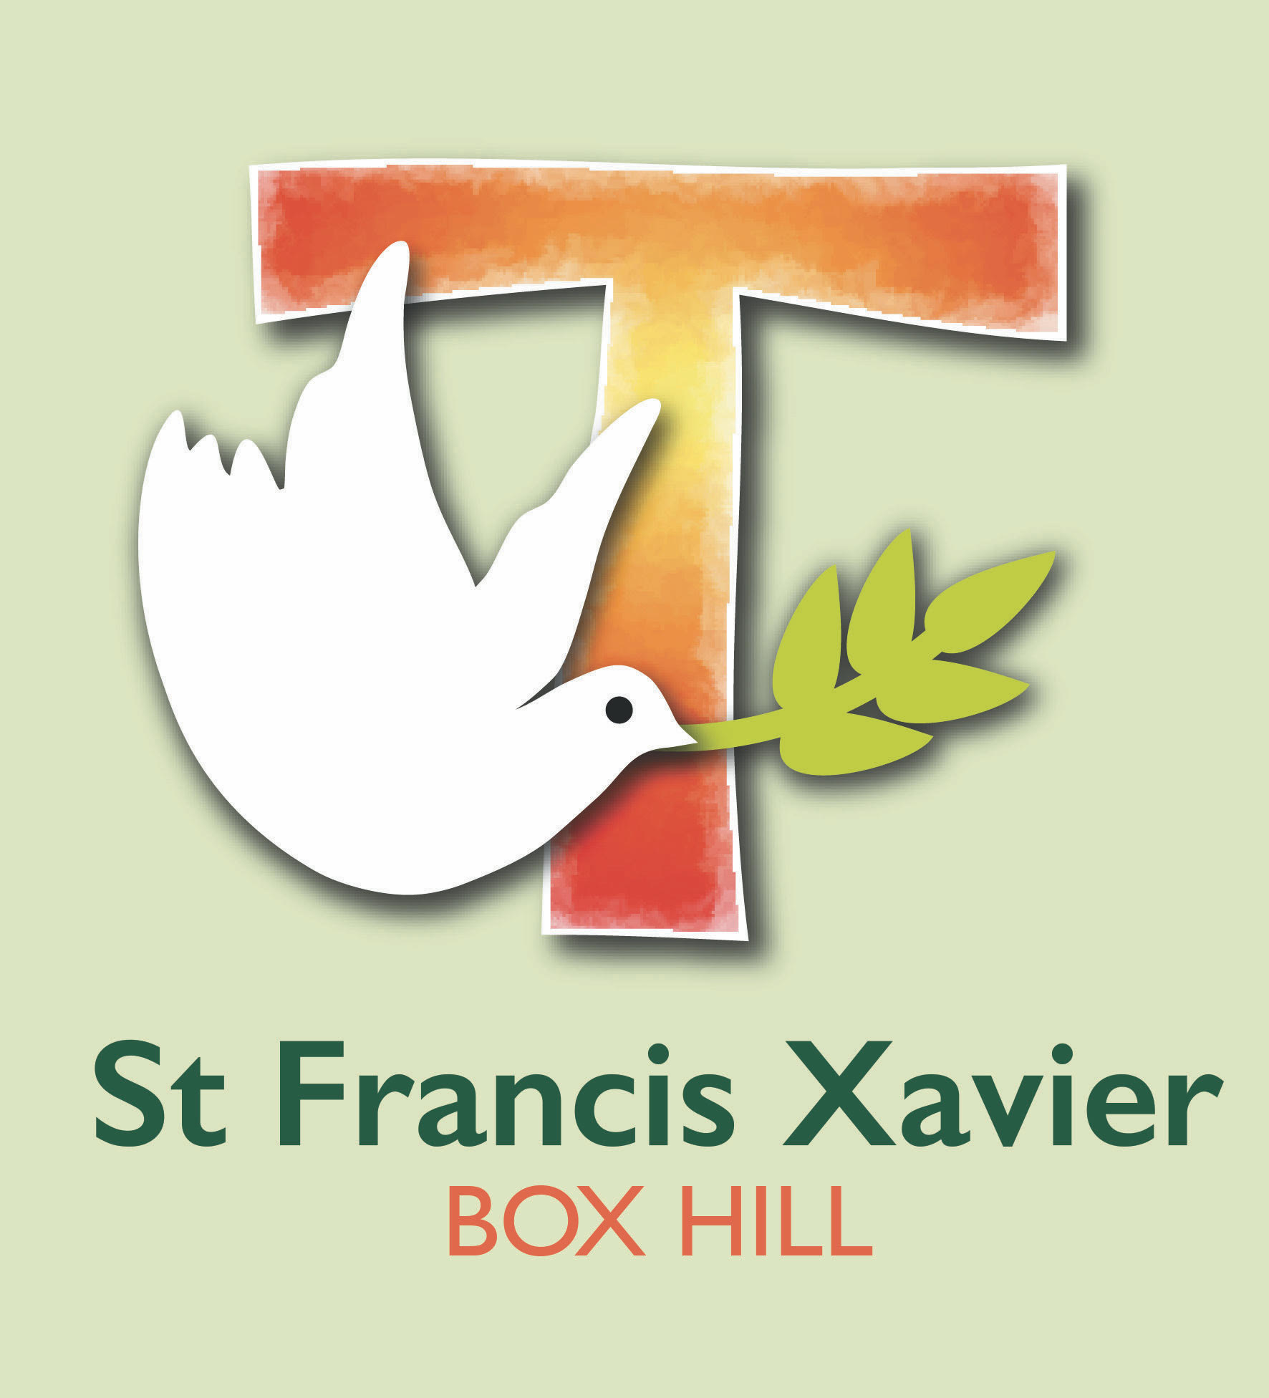
St Francis Xavier
Curriculum Plan Overview
St Francis Xavier is a school that operates with the consent of the Catholic Archbishop of Melbourne and is owned, operated and governed by Melbourne Archdiocese Catholic Schools Ltd (MACS).

Curriculum and Learning Policy

Vision
School Motto: "Let Happiness Dwell Here"
In the Franciscan spirit, our vision is for a school that:
1 Catholic Tradition
Is grounded in Catholic tradition and spirituality, in which the Gospel values of trust, respect, forgiveness and care underpin everyday teaching and learning.
2 Learning environment
Provides a high-quality learning environment that:
- Cultivates effective learners-for-life through a commitment to informed and current teaching and learning practices.
- Values the key role teachers play in supporting the personal growth of children, recognising that they are responsible for enhancing the quality and standard of student learning outcomes.
- Consistently offers learning activities involving the continuing acquisition of knowledge and skills so that learners can apply these critically to understand and participate effectively as responsible citizens in their world.
3 Environment
Encourages respect, responsibility and care for creation; where an awareness of the environment and its species is developed and promoted
4 Wellbeing
Enhances the well being of all in an environment of justice, inclusiveness, tolerance, equality and compassion; in which harmony and healthy relationships are promoted through the development of social skills, self-worth, affirmation and the celebration of achievements
5 Collaboration
Is a learning community in which teamwork and collaboration are central to everyday practice
6 Community
Is a place in which clergy, parents, teachers and students build and nurture a healthy growing community

Accredited Curriculum Overview

Foundation to Year 10
The Victorian Curriculum F–10 is the Foundation to Year 10 curriculum for Victorian government and Catholic schools. The Victorian Curriculum reflects Victorian priorities and standards for F–10 and defines what it is that all students have the opportunity to learn as a result of their schooling, set out as a series of learning progressions.
The Victorian Curriculum F–10 can be found here: http://www.vcaa.vic.edu.au/pages/foundation10/f10index.aspx
The Victorian Curriculum F–10 recognises that increasingly, in a world where knowledge itself is constantly growing and evolving, students need to develop discrete discipline knowledge and understanding, in addition to a set of skills, behaviours and dispositions. These general capabilities apply across discipline content and equip students to be lifelong learners able to operate with confidence in a complex, information-rich, globalised world.
The St Francis Xavier Curriculum Plan has been developed in light of the directions for Catholic education, the Religious Education Curriculum Framework, the Victorian Curriculum F–10 and/or senior secondary curriculum and principles of curriculum from the Horizons of Hope education framework. This curriculum plan ensures excellent holistic education, centred on the students and engaging them in authentic, purposeful learning.

Scope
Our school curriculum defines what it is that all students have the opportunity to learn as a result of their schooling at St Francis Xavier.
At St Francis Xavier, the curriculum is enriched by the values, beliefs, perspectives and experiences of each member of the learning community when they engage actively with Catholic understandings of the human person. This orientation towards the person means that the process of curriculum design is shared with students, creating within them a sense of ownership and self-efficacy as learners. Our learning community fosters the conditions for students to have a voice in the curriculum design process, allowing them to contribute to decisions about what they need to know and when.

Curriculum Content
St Francis Xavier will take inspiration from the Horizons of Hope education framework. This framework supports MACS school communities to engage in dialogue about the distinctive nature of learning and teaching, leading learning, and enhancing Catholic identity in our schools. The framework is a living document that has been added to over the years with examples of practice from schools, as well as additional strategy statements in the areas of Religious Education, Leadership, Wellbeing and Diversity.
Religious Education has a central place in the teaching and learning program at St Francis Xavier as it reflects our unique character of Catholic identity and focus as a MACS school. The primary source for developing our religious education program is the MACS Religious Education Curriculum Framework.
The school implements the Victorian Curriculum F–10 in order to provide students with a comprehensive teaching and learning program across the year levels with age-appropriate content, sequential learning patterns and interrelated aspects of the content and skills of the desired learning capabilities. Refer to the Horizons of Hope Foundation Statement – Pedagogy in a Catholic School. The Victorian Curriculum can be found here: Victorian Curriculum F–10.
All content is developed using the following documents:
- St Francis Xavier Religious Education Scope and Sequence: Religious Education Curriculum Framework Document
- St Francis Xavier school policies for each of the learning areas
- Victorian Curriculum F–10
- Statement of Philosophy.
The school’s teaching and learning program is the school-based plan for delivering this common set of knowledge and skills in ways that best use local resources, expertise and contexts. Information technology is an integral part of our curriculum as a basic tool for learning. Supported by MACS, St Francis Xavier will develop strong processes for monitoring student progress and the application of appropriate explicit teaching and intervention strategies.

Whole-school Curriculum Plan and Time Allocation

Curriculum overview – Foundation to Year 10
The following provides an outline of the learning areas within the F–10 curriculum. Recommended weekly time allocations are listed as a guide. School curriculum plans may concentrate the teaching of particular learning areas within semester units or electives (as in the case for Years 7–10). The recommended weekly time allocations are in line with recommendations of the educational authorities and are averages of curriculum implementation which may span across the two-year cycle. Furthermore, multiple learning areas are often part of an integrated unit and not always taught as separate subject areas.
[Drafting note for schools: Each school needs to substantially address the nine curriculum areas (Religious Education plus the Victorian Curriculum learning areas), and the times listed below provide an indication of the recommended proportion of time across the curriculum. Given the flexibility of the Victorian Curriculum, each school should identify the number of hours allocated within their learning and teaching program within these guidelines. This note is to be deleted.]

Foundation to Year 10
Learning Areas | Recommended Time Allocated
Religious Education | 2 hours 30 minutes, weekly
English  - Reading and Viewing  - Speaking and Listening  - Grammar and Spelling  - Writing | 2 hours daily  Total time should not be less than 10 hours per week on average over the course of a school year and may vary across year levels.
Languages | 75 minutes per week – 15 minutes daily
Mathematics  - Number and Algebra  - Measurement and Geometry  - Statistics and Probability | 1 hour daily  Five days per week  Total time should not be less than five hours per week on average over the course of a school year.
Health and Physical Education | 2 hours 30 minutes weekly
The Arts | 1 hour weekly
The Humanities  - Civics and Citizenship  - Economics and Business  - Geography  - History  Science  Technologies  - Design and Technology  - Digital Technologies | 2 hours and 15 minutes weekly  The learning areas of Science, the Humanities, Health and Physical Education, and Technologies will be taught ensuring an average of three hours per week over the course of a school year.  The focus is on the integrated unit of work using the school’s evidence-based inquiry approach.
TOTAL | 25 hours weekly

Capabilities
The Victorian Curriculum F–10 includes both knowledge and skills. It is expected that the knowledge and skills defined in the Capabilities will be developed, practised, deployed and demonstrated by students in and through their learning across the curriculum.
The four capabilities of the Victorian Curriculum F–10 are:
- Critical and Creative Thinking
- Ethical
- Intercultural
- Personal and Social.

Curriculum Overview – Senior Secondary

Victorian Certificate of Education (VCE)
The VCE is a senior secondary certificate of education recognised within the Australian Qualifications Framework (AQF). It is designed to be completed over a minimum of two years, and includes general education curriculum components (VCE studies) and programs from VET qualifications. The minimum requirement for satisfactory completion of the VCE is the satisfactory completion of 16 units which must include:
- three units from the English group, including a Unit 3–4 sequence
- at least three other sequences of Unit 3–4 studies, which can include further sequences from the English group.

Victorian Certificate of Applied Learning (VCAL)
The VCAL is a senior secondary certificate of education recognised within the Australian Qualifications Framework (AQF). The VCAL can include components of accredited Vocational Education and Training (VET) including Further Education (FE) qualifications from within the AQF, and VCE studies. The VCAL is accredited and issued at three award levels. VET training is a compulsory requirement for completion of VCAL certificates at intermediate and senior level. To be awarded any VCAL qualification, students must successfully complete a learning program that contains a minimum of 10 credits and includes:
- curriculum components that can be justified against the purpose statement for the Literacy and Numeracy Skills Strand: one credit is required for Literacy Skills and one credit is required for Numeracy Skills
- curriculum components to the value of at least one credit that can be justified against the purpose statement for each of the Work Related Skills Strand, Personal Development Skills Strand and Industry Specific Skills Strand
- a minimum of two VCAL units, one of which must be a VCAL Personal Development Skills unit at level
- curriculum components to the value of six credits at the level of the VCAL award or above – one of which must be for Literacy Skills.

Vocational Education and Training (VET)
Recognition of VET, including Further Education (FE) within the VCE and VCAL, ensures that students who complete all or part of a nationally recognised VET (including FE) qualification may receive credit towards satisfactory completion of the VCE or VCAL. Students would typically undertake training at Certificate II or III level. MACS schools are required to have appropriate courses, assessment, reporting and administrative processes in place to ensure students undertaking a VCE or VCAL program, and/or VET courses, have access to the necessary teaching and learning programs. The VCAA VCE and VCAL Administrative Handbook and the specific VCE study designs and/or VCAL curriculum guides and/or VET modules set out these requirements for all schools.

Implementation
The curriculum is designed and delivered from whole-school to year level planning to individual teacher plans. These are created in a collaborative and supported environment. This ensures that a guaranteed and viable curriculum is driving student learning and lifting student outcomes.
A variety of other resources, including online resources, are available to support planning.
[School name] will implement the curriculum plan by [to be completed].
[Drafting note for schools (Describe the processes for how the whole-school curriculum plan is translated into year level planning and individual planning, in terms of planning structures, processes and resources, for example multi-year planning groups are established to scope out sequences of learning across year levels, or year-level planning groups design units of work shared across the year levels within a two year cycle, etc). This note is to be deleted.]

Evaluation
This policy will be monitored and reviewed by the staff, in accordance with the School Improvement Plan or as required.

School Policies
[Drafting note for schools: List here all related school policies and procedures]

Scope and Sequence – [School Name] Learning and Teaching Program
[Note: the school learning and teaching program should be attached here. This will provide parents/guardians/carers/relevant person with an outline of the structure of the learning and teaching program across learning areas and year levels. The scope and sequence should show the program across two-year bands. This note should be deleted prior to publishing on the school website.]

