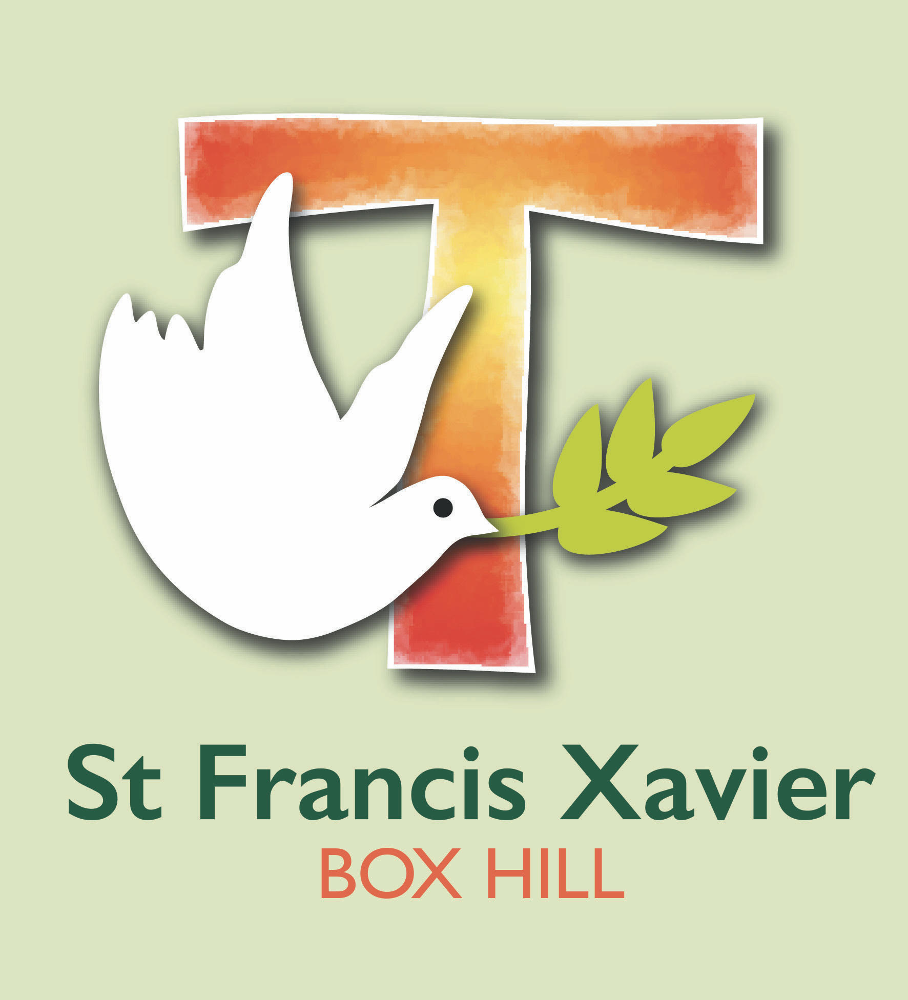
St Francis Xavier
Occupational Health and Safety Policy
St Francis Xavier is a school that operates with the consent of the Catholic Archbishop of Melbourne and is owned, operated and governed by Melbourne Archdiocese Catholic Schools Ltd (MACS).

Aim of this OHS Policy
To inform staff, students, visitors, contractors and volunteers that OHS is an integral part of all operations at St Francis Xavier.

Who has ultimate authority and responsibility for OHS in this school?
The daily administration of OHS matters has been delegated to the school Principal Mary Jones.

Commitment to OHS
St Francis Xavier and its management is committed to:
- providing a safe and healthy workplace to staff, students, visitors, contractors and other parties
- ensuring that our school can meet its OHS obligations
- providing OHS information, training and supervision to employees and other relevant parties
- consulting with employees (and their representatives), managers and other stakeholders on OHS issues
- resolving any OHS issues by following the school’s OHS Issue Resolution procedure.

Responsibilities
St Francis Xavier and its senior management is responsible for:
- providing adequate resources for implementing this policy which includes assigning responsibilities for OHS duties
- providing and maintaining safe plant and systems of work
- making and monitoring arrangements for the safe use, handling, storing and transport of plant and substances
- maintaining, so far as is reasonably practicable, a school that it is safe and without risks to physical and mental health
- providing adequate facilities for the welfare of all employees and students
- providing information, training and supervision for employees and contractors enabling them to work in a safe and healthy manner.
Employees, contractors and sub-contractors will be responsible for:
- fulfilling their duties under OHS legislation and acting in a safe manner
- taking reasonable care of their own health and safety and that of others affected by their actions
- complying with the safety procedures and directions. Acting in accordance with agreed school procedures for accident and incident reporting and reporting potential hazards to the Principal or his/her representative.

Review
St Francis Xavier is committed to the continual improvement of its OHS performance.
Authorised by: Principal
Signature: 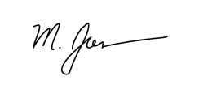 |  | Date: 04/06/2021

Policy ratified by School Leadership Team: 3 November 2021
The person responsible: Mary Jones
Next review date: 3 November 2022Relevant Legislation
Victorian Occupational Health and Safety Act 2004

Related school policies
Essential Safety Measures Policy
First Aid Procedures

Related documents
OHS Issue Resolution Flowchart
OHS Induction Checklist

External resources
WorkSafe Victoria 2017 OHS in schools: A practical guide for school leaders

